**Image Recognition with IBM Cloud Visual Recognition**

# Emotion Recognition in Image Captioning Emotion recognition adds a new dimension to image captioning by detecting and expressing the emotions depicted in the image. With the help of advanced algorithms, images can be analyzed to identify emotions such as joy, sadness, surprise, and more.

**Project Update:**

We have created a website to upload and display Images

**Future Development of the Project:**

The website will be AI generated to caption the emotions in the uploaded image

**Source Code:**

**HTML Code**

<!DOCTYPE html>

<html lang="en">

<head>

<meta charset="UTF-8">

<title>Image Upload</title>

<link rel="stylesheet" href="style.css">

</head>

<body>

<div class="container">

<h1>Image Upload</h1>

<form id="upload-form" enctype="multipart/form-data">

<input type="file" name="file" id="file-input" accept="image/*">

<button type="submit">Upload</button>

</form>

<div id="preview">

<img id="image-preview" src="" alt="Image Preview">

</div>

</div>

<script src="script.js"></script>

</body>

</html>

**CSS Code**

body {

font-family: Arial, sans-serif;

}

.container {

max-width: 400px;

margin: 0 auto;

text-align: center;

}

h1 {

margin-top: 20px;

}

form {

margin: 20px 0;

}

input[type="file"] {

display: none;

}

button {

padding: 10px 20px;

background-color: #007BFF;

color: #fff;

border: none;

cursor: pointer;

}

button:hover {

background-color: #0056b3;

}

#preview {

display: none;

margin-top: 20px;

}

#image-preview {

max-width: 100%;

}

**Javascript Code**

const fileInput = document.getElementById('file-input');

const imagePreview = document.getElementById('image-preview');

fileInput.addEventListener('change', function () {

const file = fileInput.files[0];

if (file) {

const reader = new FileReader();

reader.onload = function (e) {

imagePreview.src = e.target.result;

document.getElementById('preview').style.display = 'block';

};

reader.readAsDataURL(file);

}

});

const uploadForm = document.getElementById('upload-form');

uploadForm.addEventListener('submit', function (e) {

e.preventDefault();

const formData = new FormData(uploadForm);

// Use formData to upload the file to the server or perform any necessary processing

// Example: Send the formData to the server using a fetch request or an XMLHttpRequest

});

const fileInput = document.getElementById('file-input');

const imagePreview = document.getElementById('image-preview');

fileInput.addEventListener('change', function () {

const file = fileInput.files[0];

if (file) {

const reader = new FileReader();

reader.onload = function (e) {

imagePreview.src = e.target.result;

document.getElementById('preview').style.display = 'block';

};

reader.readAsDataURL(file);

}

});

const uploadForm = document.getElementById('upload-form');

uploadForm.addEventListener('submit', function (e) {

e.preventDefault();

const formData = new FormData(uploadForm);

// Use formData to upload the file to the server or perform any necessary processing

// Example: Send the formData to the server using a fetch request or an XMLHttpRequest

});

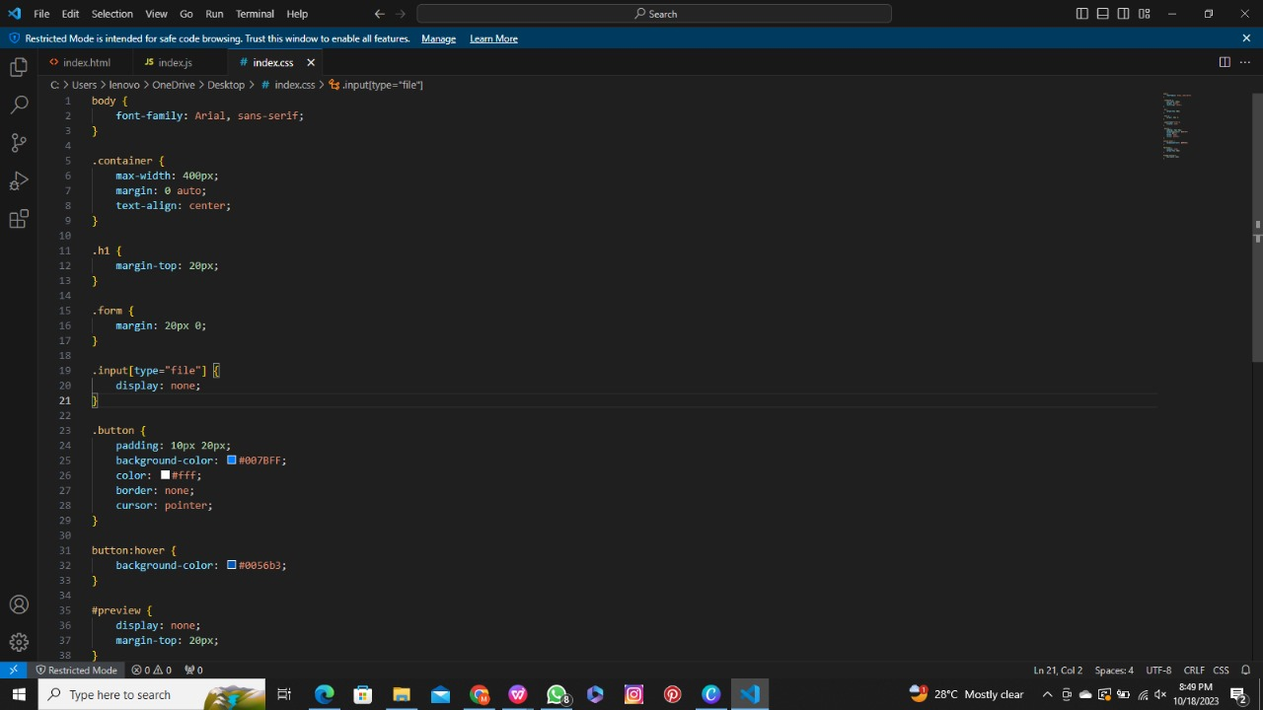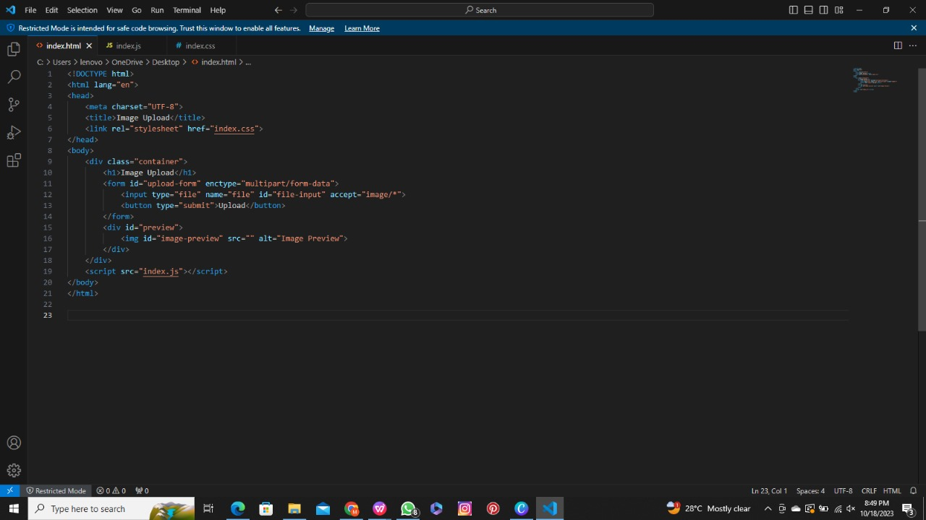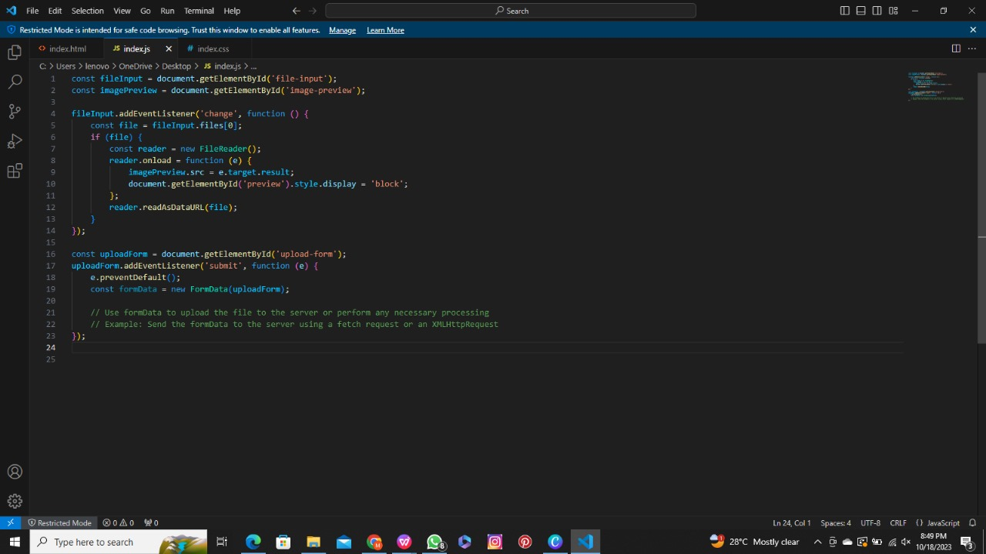

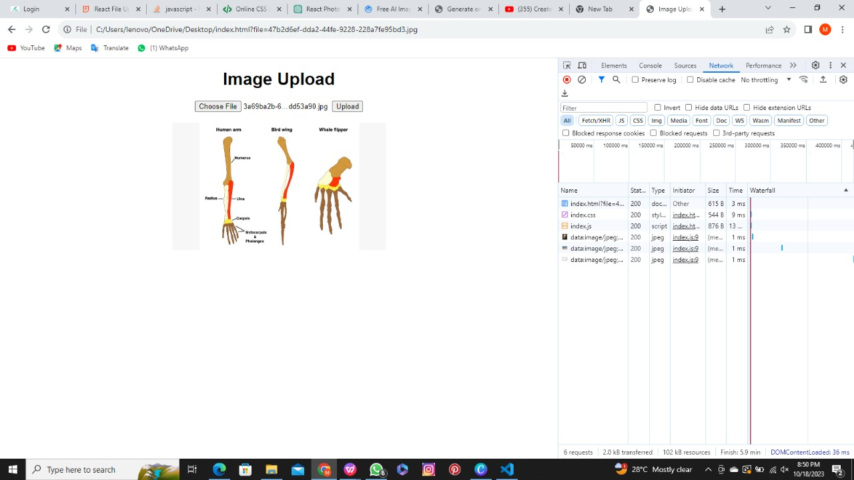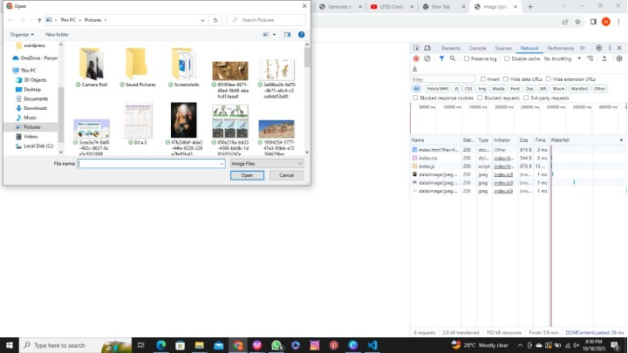

Step 2: Setting up Data for the AI Model

Before running the scripts for the image recognition project, it's crucial to set up the required datasets. Collecting the dataset for emotion captioning includes several steps,

1.define your emotion Categories

2.Data source selection

3.Data collection

4.Emotion labeling

1.Define your emotion Categories:

**The set of distinct emotional states or labels used to categorize and describe human emotions based on their characteristics and expressions.**

The seven primary emotion categories are:

* neutral
* happy
* surprise
* sad
* angry
* disgust
* fear

2.Data source selection:

SOURCE:

<https://www.kaggle.com/datasets>

DESCRIPTION: Kaggle Datasets serves as a valuable resource for data enthusiasts, offering detailed descriptions, documentation, and metadata to assist in dataset selection.

<https://github.com/microsoft/FERPlus>

DESCRIPTION: FERPlus is an extension of the FER-13 dataset, providing a more refined annotation of emotions. It includes additional labels, offering improved granularity in emotion recognition.

[COCO Dataset](https://cocodataset.org/)

DESCRIPTION: The COCO Dataset is a widely recognized and extensively used dataset in the field of computer vision and machine learning. It is designed for various computer vision tasks, including object detection, image segmentation, and captioning.

3.Data collection:

To run the image recognition scripts successfully, we should follow these steps,

* Download the CK+, FER-13, and FERPlus datasets from their respective sources.
* Organizing the dataset files according to our project's directory structure.
* The collection of data could be facial images, text, audio recordings, or any other relevant data.

REORGANIZATION OF DATA:

* Images are transferred from the original FERPlus directory structure to match the FER-2013 structure.
* Images are categorized into training and test sets based on the "Usage" attribute in the CSV file.

EXECUTION:

The Python script appears to be related to data preprocessing and reorganizing image data from two different datasets: the "FERPlus" dataset and the "FER-2013" dataset, which are used in the context of facial expression recognition.

import os

import shutil

import cv2

import numpy as np

import pandas as pd

def get_best_emotion(list_of_emotions, emotions):

best_emotion = np.argmax(emotions)

if best_emotion == "neutral" and sum(emotions[1::]) > 0:

emotions[best_emotion] = 0

best_emotion = np.argmax(emotions)

return list_of_emotions[best_emotion]

def read_and_clean_csv(path):

# we read the csv and we delete all the rows which contains NaN

df = pd.read_csv(path)

df = df.dropna()

return df

def rewrite_image_from_df(df):

print("Moving images from FERPlus inside FER-2013")

# we setup an accumulator to print if we have finished a task

acc = ""

emotions = [

"neutral",

"happy",

"surprise",

"sad",

"angry",

"disgust",

"fear",

"contempt",

"unknown",

"NF",

]

# we rewrite all the image files

for row in range(len(df)):

item = df.iloc[row]

if item["Usage"] not in ["", acc]:

print(f"{item['Usage']} done")

if (item['Usage'] == "Training"):

image = cv2.imread(f"./FERPlus/output/FER2013Train/{item['Image name']}")

elif item['Usage'] == "PublicTest":

image = cv2.imread(f"./FERPlus/output/FER2013Valid/{item['Image name']}")

else:

image = cv2.imread(f"./FERPlus/output/FER2013Test/{item['Image name']}")

acc = item["Usage"]

if acc == "Training":

cv2.imwrite(

f"./FER-2013/train/{get_best_emotion(emotions, item[2::])}/{item['Image name']}",

image,

)

else:

cv2.imwrite(

f"./FER-2013/test/{get_best_emotion(emotions, item[2::])}/{item['Image name']}",

image,

)

if __name__ == "__main__":

os.system('python ./FERPLUS/src/generate_training_data.py -d ./FERPLUS/output -fer ./FER-2013/fer2013.csv -ferplus ./FERPLUS/fer2013new.csv')

df = read_and_clean_csv("./FERPlus/fer2013new.csv")

rewrite_image_from_df(df)

4.Emotion labeling:

The FERPlus dataset provides emotion labels in a detailed format.

SEVEN PRIMARY CATEGORIES:

* neutral, happy, surprise, sad, angry, disgust, and fear.

SORTING OF IMAGES BASED ON EMOTION:

Sorting images into subfolders based on the dominant emotion category they represent is a common practice in organizing image datasets for emotion recognition and other image classification tasks.

<?xml version="1.0"?>

<opencv_storage>

<cascade type_id="opencv-cascade-classifier"><stageType>BOOST</stageType>

<featureType>HAAR</featureType>

<height>24</height>

<width>24</width>

<stageParams>

<maxWeakCount>211</maxWeakCount></stageParams>

<featureParams>

<maxCatCount>0</maxCatCount></featureParams>

<stageNum>25</stageNum>

<stages>

<_>

<maxWeakCount>9</maxWeakCount>

<stageThreshold>-5.0425500869750977e+00</stageThreshold>

<weakClassifiers>

<_>

<internalNodes>

0 -1 0 -3.1511999666690826e-02</internalNodes>

<leafValues>

2.0875380039215088e+00 -2.2172100543975830e+00</leafValues></_>

<_>

<internalNodes>

0 -1 1 1.2396000325679779e-02</internalNodes>

<leafValues>

-1.8633940219879150e+00 1.3272049427032471e+00</leafValues></_>

<_>

<internalNodes>

0 -1 2 2.1927999332547188e-02</internalNodes>

<leafValues>

-1.5105249881744385e+00 1.0625729560852051e+00</leafValues></_>

<_>

<internalNodes>

0 -1 3 5.7529998011887074e-03</internalNodes>

<leafValues>

-8.7463897466659546e-01 1.1760339736938477e+00</leafValues></_>

<_>

<internalNodes>

0 -1 4 1.5014000236988068e-02</internalNodes>

<leafValues>

-7.7945697307586670e-01 1.2608419656753540e+00</leafValues></_>

<_>

<internalNodes>

0 -1 5 9.9371001124382019e-02</internalNodes>

<leafValues>

5.5751299858093262e-01 -1.8743000030517578e+00</leafValues></_>

<_>

<internalNodes>

0 -1 6 2.7340000960975885e-03</internalNodes>

<leafValues>

-1.6911929845809937e+00 4.4009700417518616e-01</leafValues></_>

<_>

<internalNodes>

0 -1 7 -1.8859000876545906e-02</internalNodes>

<leafValues>

-1.4769539833068848e+00 4.4350099563598633e-01</leafValues></_>

<_>

<internalNodes>

0 -1 8 5.9739998541772366e-03</internalNodes>

<leafValues>

-8.5909199714660645e-01 8.5255599021911621e-01</leafValues></_></weakClassifiers></_>

<_>

<maxWeakCount>16</maxWeakCount>

<stageThreshold>-4.9842400550842285e+00</stageThreshold>

<weakClassifiers>

<_>

<internalNodes>

0 -1 9 -2.1110000088810921e-02</internalNodes>

<leafValues>

1.2435649633407593e+00 -1.5713009834289551e+00</leafValues></_>

<_>

<internalNodes>

0 -1 10 2.0355999469757080e-02</internalNodes>

<leafValues>

-1.6204780340194702e+00 1.1817760467529297e+00</leafValues></_>

<_>

<internalNodes>

0 -1 11 2.1308999508619308e-02</internalNodes>

<leafValues>

-1.9415930509567261e+00 7.0069098472595215e-01</leafValues></_>

<_>

<internalNodes>

0 -1 12 9.1660000383853912e-02</internalNodes>

<leafValues>

-5.5670100450515747e-01 1.7284419536590576e+00</leafValues></_>

<_>

<internalNodes>

0 -1 13 3.6288000643253326e-02</internalNodes>

<leafValues>

2.6763799786567688e-01 -2.1831810474395752e+00</leafValues></_>

<_>

<internalNodes>

0 -1 14 -1.9109999760985374e-02</internalNodes>

<leafValues>

-2.6730210781097412e+00 4.5670801401138306e-01</leafValues></_>

<_>

<internalNodes>

0 -1 15 8.2539999857544899e-03</internalNodes>

<leafValues>

-1.0852910280227661e+00 5.3564202785491943e-01</leafValues></_>

<_>

<internalNodes>

0 -1 16 1.8355000764131546e-02</internalNodes>

<leafValues>

-3.5200199484825134e-01 9.3339198827743530e-01</leafValues></_>

<_>

<internalNodes>

0 -1 17 -7.0569999516010284e-03</internalNodes>

<leafValues>

9.2782098054885864e-01 -6.6349899768829346e-01</leafValues></_>

<_>

<internalNodes>

0 -1 18 -9.8770000040531158e-03</internalNodes>

<leafValues>

1.1577470302581787e+00 -2.9774799942970276e-01</leafValues></_>

<_>

<internalNodes>

0 -1 19 1.5814000740647316e-02</internalNodes>

<leafValues>

-4.1960600018501282e-01 1.3576040267944336e+00</leafValues></_>

<_>

<internalNodes>

0 -1 20 -2.0700000226497650e-02</internalNodes>

<leafValues>

1.4590020179748535e+00 -1.9739399850368500e-01</leafValues></_>

<_>

<internalNodes>

0 -1 21 -1.3760800659656525e-01</internalNodes>

<leafValues>

1.1186759471893311e+00 -5.2915501594543457e-01</leafValues></_>

<_>

<internalNodes>

0 -1 22 1.4318999834358692e-02</internalNodes>

<leafValues>

-3.5127198696136475e-01 1.1440860033035278e+00</leafValues></_>

<_>

<internalNodes>

0 -1 23 1.0253000073134899e-02</internalNodes>

<leafValues>

-6.0850602388381958e-01 7.7098500728607178e-01</leafValues></_>

<_>

<internalNodes>

0 -1 24 9.1508001089096069e-02</internalNodes>

<leafValues>

3.8817799091339111e-01 -1.5122940540313721e+00</leafValues></_></weakClassifiers></_>

<_>

<maxWeakCount>27</maxWeakCount>

<stageThreshold>-4.6551899909973145e+00</stageThreshold>

<weakClassifiers>

<_>

<internalNodes>

0 -1 25 6.9747000932693481e-02</internalNodes>

<leafValues>

-1.0130879878997803e+00 1.4687349796295166e+00</leafValues></_>

<_>

<internalNodes>

0 -1 26 3.1502999365329742e-02</internalNodes>

<leafValues>

-1.6463639736175537e+00 1.0000629425048828e+00</leafValues></_>

<_>

<internalNodes>

0 -1 27 1.4260999858379364e-02</internalNodes>

<leafValues>

4.6480301022529602e-01 -1.5959889888763428e+00</leafValues></_>

<_>

<internalNodes>

0 -1 28 1.4453000389039516e-02</internalNodes>

<leafValues>

-6.5511900186538696e-01 8.3021801710128784e-01</leafValues></_>

<_>

<internalNodes>

0 -1 29 -3.0509999487549067e-03</internalNodes>

<leafValues>

-1.3982310295104980e+00 4.2550599575042725e-01</leafValues></_>

<_>

<internalNodes>

0 -1 30 3.2722998410463333e-02</internalNodes>

<leafValues>

-5.0702601671218872e-01 1.0526109933853149e+00</leafValues></_>

<_>

<internalNodes>

0 -1 31 -7.2960001416504383e-03</internalNodes>

<leafValues>

3.6356899142265320e-01 -1.3464889526367188e+00</leafValues></_>

<_>

<internalNodes>

0 -1 32 5.0425000488758087e-02</internalNodes>

<leafValues>

-3.0461400747299194e-01 1.4504129886627197e+00</leafValues></_>

<_>

<internalNodes>

0 -1 33 4.6879000961780548e-02</internalNodes>

<leafValues>

-4.0286201238632202e-01 1.2145609855651855e+00</leafValues></_>

<_>

<internalNodes>

0 -1 34 -6.9358997046947479e-02</internalNodes>

<leafValues>

1.0539360046386719e+00 -4.5719701051712036e-01</leafValues></_>

<_>

<internalNodes>

0 -1 35 -4.9033999443054199e-02</internalNodes>

<leafValues>

-1.6253089904785156e+00 1.5378999710083008e-01</leafValues></_>

<_>

<internalNodes>

0 -1 36 8.4827996790409088e-02</internalNodes>

<leafValues>

2.8402999043464661e-01 -1.5662059783935547e+00</leafValues></_>

.

(30000 lines in between)

.

.

<_>

<rects>

<_>

0 13 18 3 -1.</_>

<_>

0 14 18 1 3.</_></rects></_>

<_>

<rects>

<_>

15 17 9 6 -1.</_>

<_>

15 19 9 2 3.</_></rects></_>

<_>

<rects>

<_>

0 17 9 6 -1.</_>

<_>

0 19 9 2 3.</_></rects></_>

<_>

<rects>

<_>

12 17 9 6 -1.</_>

<_>

12 19 9 2 3.</_></rects></_>

<_>

<rects>

<_>

3 17 9 6 -1.</_>

<_>

3 19 9 2 3.</_></rects></_>

<_>

<rects>

<_>

16 2 3 20 -1.</_>

<_>

17 2 1 20 3.</_></rects></_>

<_>

<rects>

<_>

0 13 24 8 -1.</_>

<_>

0 17 24 4 2.</_></rects></_>

<_>

<rects>

<_>

9 1 6 22 -1.</_>

<_>

12 1 3 11 2.</_>

<_>

9 12 3 11 2.</_></rects></_></features></cascade>

</opencv_storage>

EXECUTION

**The provided XML code represents a Haar Cascade Classifier, a machine learning model used for detecting frontal faces in images. Haar Cascade Classifiers are a type of object detection algorithm commonly used in computer vision for recognizing objects, such as faces, within images.**

Developing and Fine-Tuning Deep Learning Models for Emotion Recognition:

**The central focus is on the development and fine-tuning of deep learning models for precise emotion recognition**, outlining the essential steps in the process,

DATA PREPROCESSING:

**The role of data preprocessing in training emotion recognition models. It highlights the use of techniques like data augmentation, specifically leveraging Keras' ImageDataGenerator. Data augmentation is employed to improve the model's capacity to identify emotions from diverse facial expressions.**

ARCHITECTURE SELECTION:

**The readers introduce range of pre-trained architectures, such as VGG16, ResNet50, Xception, and Inception, which form the basis for emotion recognition models.**

**Fine-Tuning for Optimal Performance:**

**The importance of fine-tuning in model development, emphasizing its role in adapting the model for a specific task. It discusses the process of selecting and configuring the layers that require retraining to achieve optimal model performance.**

Monitoring and Evaluation:

The use of Matplotlib for visualizing training and validation metrics, enabling developers to gain insights into the model's progress and effectiveness.

Saving and Reusing Models:

Developers are guided on saving their trained models for future use, enabling them to deploy these models in various applications with consistent performance.

from glob import glob

from keras import Model

from keras.callbacks import EarlyStopping

from keras.layers import Flatten, Dense

from keras.models import save_model

from keras.optimizer_v2.gradient_descent import SGD

from keras_preprocessing.image import ImageDataGenerator

def get_data(parameters, preprocess_input: object) -> tuple:

image_gen = ImageDataGenerator(

# rescale=1 / 127.5,

rotation_range=20,

zoom_range=0.05,

shear_range=10,

horizontal_flip=True,

fill_mode="nearest",

validation_split=0.20,

preprocessing_function=preprocess_input,

)

# create generators

train_generator = image_gen.flow_from_directory(

parameters["train_path"],

target_size=parameters["shape"],

shuffle=True,

batch_size=parameters["batch_size"],

)

test_generator = image_gen.flow_from_directory(

parameters["test_path"],

target_size=parameters["shape"],

shuffle=True,

batch_size=parameters["batch_size"],

)

return (

glob(f"{parameters['train_path']}/*/*.jp*g"),

glob(f"{parameters['test_path']}/*/*.jp*g"),

train_generator,

test_generator,

)

def fine_tuning(model: Model, parameters):

# fine tuning

for layer in model.layers[: parameters["number_of_last_layers_trainable"]]:

layer.trainable = False

return model

def create_model(architecture, parameters):

model = architecture(

input_shape=parameters["shape"] + [3],

weights="imagenet",

include_top=False,

classes=parameters["nbr_classes"],

)

# Freeze existing VGG already trained weights

for layer in model.layers[: parameters["number_of_last_layers_trainable"]]:

layer.trainable = False

# get the VGG output

out = model.output

# Add new dense layer at the end

x = Flatten()(out)

x = Dense(parameters["nbr_classes"], activation="softmax")(x)

model = Model(inputs=model.input, outputs=x)

opti = SGD(

lr=parameters["learning_rate"],

momentum=parameters["momentum"],

nesterov=parameters["nesterov"],

)

model.compile(loss="categorical_crossentropy", optimizer=opti, metrics=["accuracy"])

# model.summary()

return model

def fit(model, train_generator, test_generator, train_files, test_files, parameters):

early_stop = EarlyStopping(monitor="val_accuracy", patience=2)

return model.fit(

train_generator,

validation_data=test_generator,

epochs=parameters["epochs"],

steps_per_epoch=len(train_files) // parameters["batch_size"],

validation_steps=len(test_files) // parameters["batch_size"],

callbacks=[early_stop],

)

def evaluation_model(model, test_generator):

score = model.evaluate_generator(test_generator)

print("Test loss:", score[0])

print("Test accuracy:", score[1])

return score

def saveModel(filename, model):

save_model(model=model, filepath=f"./trained_models/{filename}")

model.save_weights(f"./trained_models/{filename}.h5")

Conclusion:

In the fifth phase of our image recognition development, we focused on aspects of data preparation, Haar Cascade Classifier for face detection, and the creation and fine-tuning of deep learning models for emotion recognition. We recognized the foundational importance of well-organized and preprocessed datasets in training accurate image recognition models. The exploration of the Haar Cascade Classifier highlighted its efficiency in detecting faces in images, making it a valuable tool for a wide range of computer vision applications. It also involved the development of powerful deep learning models, utilizing pre-trained architectures like VGG16, ResNet50, Xception, and Inception, and adapting them for emotion recognition. These models are poised to deliver impressive levels of accuracy.